Ron’s notes
November 19, 2018

Yang article

An indigenous view of the Self
Compare with other indigenous approaches – Sundararajan, Ting, for example
From a “person-making” perspective
Compare with Gjerde’s “person-centred” cultural psychology

“… to construct, based on local materials and observations, a set of commonly shared meaning systems with which the people under investigation make sense of their lives and their experiences, and give out and derive meanings while interacting with each other…”

Historical investigation through study of evolution of Chinese written characters
Agency and dynamics
Essentialism

Exploring the individual – culture relationship (recall Greenfield)
A two-tiered meaning system
Small self and large self

Yin/Yang mode of thinking
Ting’s story of the wandering horse
Any relationship involving actions of an actor

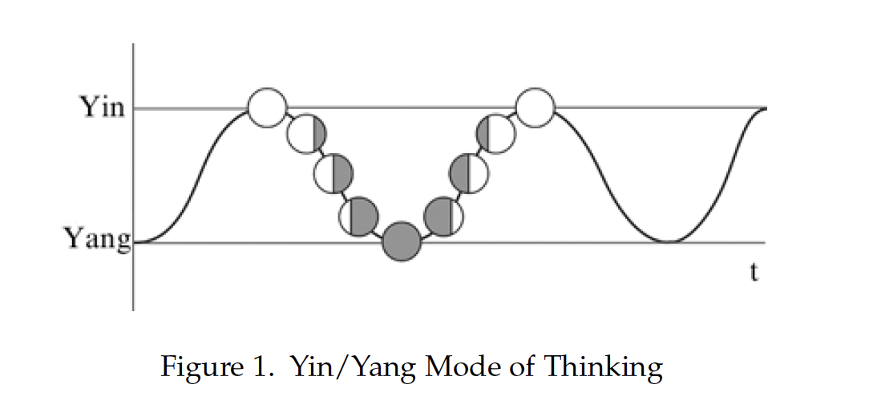
Investigating the origin and development of the character for I, pronounced “wo”
我
The mandate of heaven
Li – a set of role expectations emphasizing relationship to heaven and society, not to self
Different li depending on status, gender, occasion
De – a feeling of accomplishment from practicing li
Jiang – a feeling of humbleness and acceptance of need to improve in relation to society
Li, de and jiang all show mutual interaction between mind and body

Gentlemen and commoners (“Jun zi” and “xiao ren”)
Confucian notion of people as indispensable for achieving society goals
Responsibility to cultivate themselves and maintain social order/harmony
Social order through self-cultivation (differences in degree)
Benevolence, conscience, morality, intellect and the heart/mind character “xin”
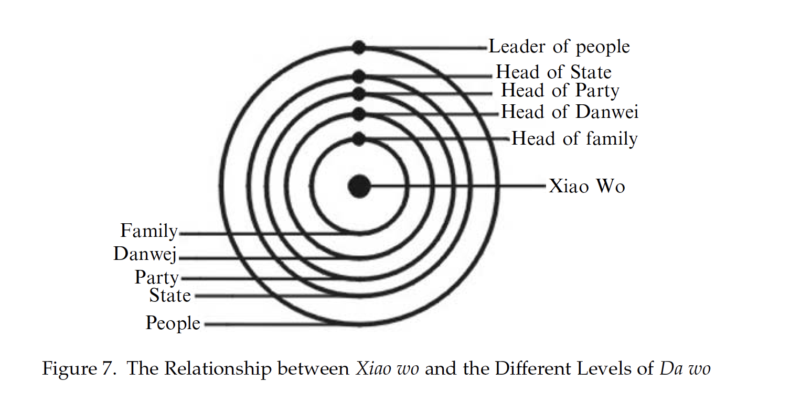
Recall Durkin’s “middle way”, here called “zhong yong”
Relation to yin/yang
A way to person-making
The attempt to maintain harmonious relationships with the rest of the world through self-growth

Relationships that preoccupy the Chinese mind
Da wo, xiao wo, and a person’s value
Public and private – sincerity, loyalty, trust
Gentleman and hypocrite

Self-regard in relation to shared cultural model of the person – the goal of approaching the culturally ideal person

The Western conception of the self as individuated and autonomous casts a long shadow.
Tapp article

Academic literacies – reading, writing, library research
Framing the curriculum for participation

Barriers vs. bridges to the academic community/culture
A culture of ideas and arguments
Analysis, criticism, evidence and argument

Periphery of the culture, exclusion from the culture
Durkin’s international MA students
Bhatia’s caste workers
Immigrants to a foreign land, and a few natives
‘Other’ ways of writing

Novice/expert
Apprenticeship (Steinberg’s printers)
Legitimate peripheral participation
Moving to full participation
“learning to use the cultural tools of the community and constructing an identity as a member of the community of practice” (p 713-714)
Rogoff’s cultural tools
Hazing
Gaining cultural capital – cultural tools of the community
Buying status, buying meaning-making capability

Communities of Practice heuristic
Participation and reification: a duality of meaning (negotiation)
Consider the words “analysis” and “argument”
Providing support for participation, Presenting reifications
Implications of adopting a relativist epistemology, social realist epistemology

Bernstein’s conceptualization of educational knowledge
Classification: Boundaries re legitimacy
May vary with subject areas, courses,
Weak, strong
Rules of the game – visible or invisible
Recognition and realisation rules
Recognizing what’s relevant vs. being able to act appropriately
“Framing” a course or assignment
Selection, instruction, evaluation
For recognition, for participation
Strong framing good for former, insufficient for latter
Using the tacit, cultural knowledge of the academy

Tapp’s interventions
Use of shared participation exercises
Understanding knowledge as “constructed, debated and contested”
Dialogic argumentation
Moving towards legitimate participation (in the powerful ways of making meaning) through guided dialogue with others on the periphery

Relation to Bruner (coming up next week) and Rogoff in the emphasis on meaning-making in mutual learning cultures
How communities of practice perpetuate themselves and evolve
How cultures perpetuate themselves and evolve
What does the Tapp article contribute to our understanding of psychological aspects of culture?

